Artificial intelligence in engineering
Introduction
- Developments in Artificial Intelligence (AI) are such that a position in the university curriculum is justified. Why? Because tools, sensors and other equipment is increasing based on AI and an engineer should be able to put its reliability, robustness and other qualities into perspective.
- Only with ‘hands-on’ training one can get a proper appreciation of the qualities and limitations of a certain technique. The lab should be organised in such a way that the students actively participate. Groups of 2 students is the best way to organize the labs.
- At the moment the majority of applications are based on image processing / computer vision. Techniques in this area get more and more mature.
- Is it necessary to teach AI if there is so much available on the internet? From the internet they can easily grasp the basics of the technique. However, by doing so students might get a biased or partial view on AI. In a course the students are also exposed to limitations, impact of errors, robustness, etc.
- Strong focus on integration of AI with other components of the design like instrumentation, data communication, etc. The engineer is primarily the architect/integrator. The integration is the innovation.
- In many applications knowledge of the application area is important/essential.

What part of AI are we talking about?
We can split up the field of AI as shown in the diagram:

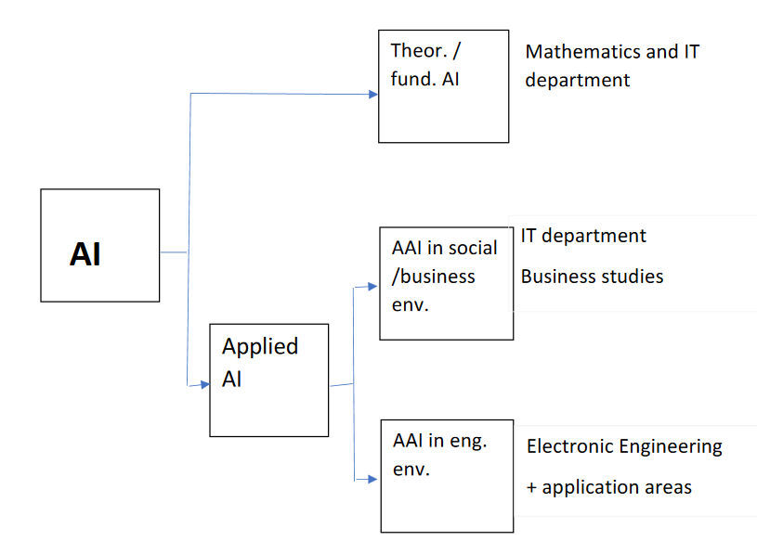

- Theoretical (fundamental) AI; an area where the IT, computer science and the mathematics department are leading. The focus is the development of new techniques, optimization of existing techniques and their performance, relation between quality and (hyper)parameters, etc.
- Applied AI in the social and business environment; the AI system interacts typically with huge quantities of data contained in databases (strongly data driven) – the Google arena
- Applied AI in the engineering environment; the AI system interacts with hardware in the form of sensors and actuators in machines, tools, control systems and industrial processes. Focus can be more on the application environment or on the technology.
Applied AI in the engineering environment typically integrates mature AI concepts in ´existing´ technical environments. The integrating role is more important than the innovator role, or, in other words, the integration of existing techniques into new products/processes is the innovation. In this integrator role it is essential to take account of overall robustness, reliability, availability and security.

What are the needs in the technical field?
Challenges range from strongly technology related to strongly related to the application area. Or in other words: situations where knowledge of the application area is less important to situations where knowledge of the application area is essential (for instance because the introduction of AI will change the process).
Where technology is leading Applied AI is found most closely to Electronic engineering due to the dominance of electronics in sensor/actuators, data communication and computer systems. A major Applied AI is justified but also the BSc graduate should be familiar with the possibilities and limitations of applied AI.
In application areas like agriculture or specific industries, a course on applied AI is justified.

Focus of a major of Electronic Engineering
- Basic AI (parameters based on best practices)
- Sensors/actuators
- Process control
- Data communication (LAN/WAN) plus high level protocols
- Databases and related high level protocols
- System integration
- Reliability, availability and access security
- Architecture of distributed systems
- Typical application areas - Internet of Things
- Social and privacy aspects of AI
The lab
Students start with the lab on sensors and actuators. In that way they get familiar with the programming language Python and the use of libraries as well as with the electronic aspects of the hardware and the specific protocols being used in present day interfaces with the physical world.
After the lab on sensors and actuators (about 40 – 60 hours) students do the AI lab. The lab uses the freely available dataset of handwritten digits. With this dataset students train a simple (convolutional) neural network.
Array operation are an important component of the lab throughout the exercises – as they are in AI in general.
The lab ends with a robot picking up a plastic bottle with a handwritten number on it. It places the bottle on a specific place according to the number.
An important focus of the lab is the reliability of the prediction of the AI network – after all the AI network is a black box that can predict anything.
A third lab on integration could be set up in which a number of intelligent devices interact. The distribution of intelligence, the interaction and the overall robustness of the system are the main focus of the lab. In this lab a number of students, each one with his/her own focus and responsibility, work together. The nature of this lab will be more that of small projects instead of predefined exercises.

Example of project: vehicular automation
One of the more difficult issues when building an AI – or any other – implementation is system robustness. A robust system continues functioning even when faults or extraordinary situations occur. The following experiment focusses on system robustness.

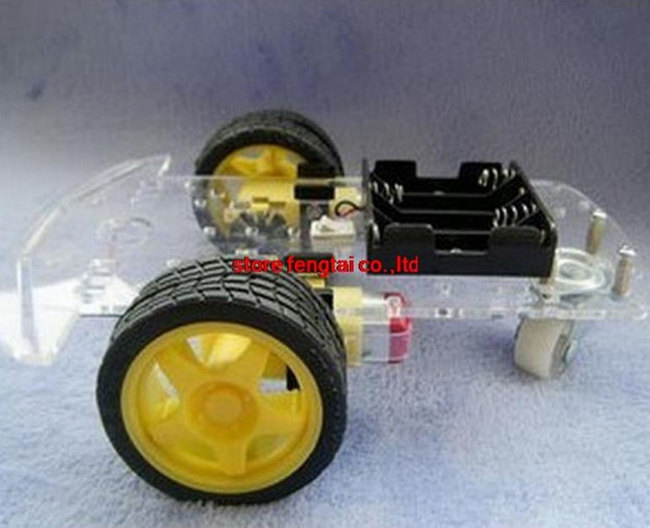
A car – one can use for instances a 2-wheel model as shown in the diagram – has a number of sensors, all related to the direction it should be moving, if it is allowed to move at all. The car is supposed to follow a white line on the dark-colored road.
The following three sensor outputs are available:
- a trained AI module based on camera input (the camera being at the front of the car);
- an infrared module (see diagram) that tells where the car is in relation to the track – the output of the sensors above a dark surface give a ‘0’ the others give a ‘1’; in that way it can keep track of a white line on a dark surface (or the other way around)
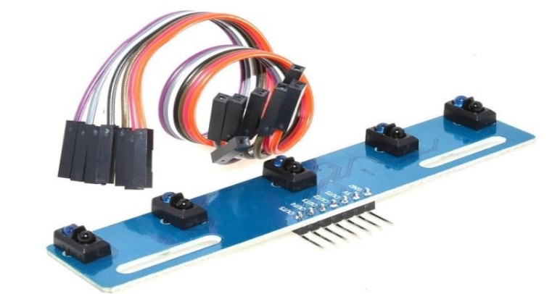
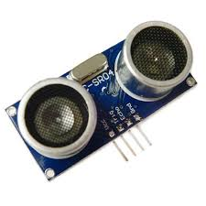

- a distance sensor at the front of the car feeding the RPi with the value of the distance towards obstacles.

The goal is to keep the car on track and avoid accidents.

First of all, each of the individual sensing units has to be made as robust as possible (individual robustness).
For the AI unit it means that the training should take into account as many of the exceptional circumstances as possible – building robust AI systems is a discipline by itself.
The other two sensors can be made robust by designing them redundantly (for instance two led-sensor combinations in parallel). In that way they can be made quite reliable.
But the bottom-line is that 100% reliability and the complete absence of conflicts can’t be reached.

One can compare the robustness of the system described above with a modern car. The driver is comparable with the AI system. His behavior has priority. However, when crossing one of the lines of the lane the car is driving in, a small counteracting force is executed on the steering mechanism. And when crossing the line when another car is passing by, an alarm goes.

Back to the experimental system with three sensors on a small car. A possible approach could be:
- chose the primary input to the program that determines the direction the car should go and whether the brakes should be applied (for simplicity we consider only the robustness of the subsystem that generates the input to the steering unit and the brakes); this signal activates the steering section and brakes
- compares the steering and brake signal from the AI unit with the two other sensor outputs for consistency
- develop a strategy and convert that into a program for all possible situations of inconsistence that can occur. The underlying considerations will be different for the steering and the brake system.

Note: apart from the three sensor inputs that we have here one could also think of systems where different cameras produce, through different AI modules, control signals that are not always consistent.

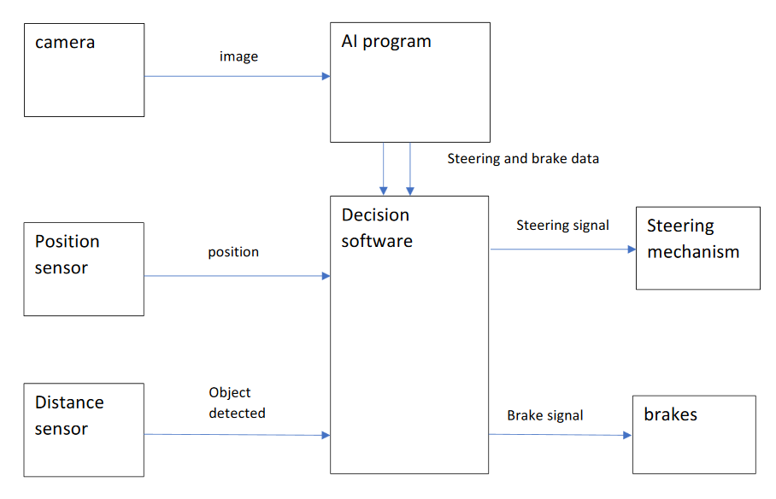

Time line:
2020
Term 1

Term 2

Term 3

2021
Term1

Term2

Term 3
Pilot lab sensors & actuators (12 students)
Year 3

(regular) lab sensors & actuators (48 -12 =36 students)
Year 3

Lab AAI (?)
(36 students)

lab sensors & actuators (48 students)

Lab AAI (?)
(36 students)

Discussion
- 2022 or 2023: start major ‘Applied Artificial Intelligence in Engineering’
- What is the better approach?
- buy sufficient Raspberries for the whole group and use them for 5 years
- split the group (half on one day, half on the other day) so that in 2 or 3 years from now the latest model can be purchased (most probably offering additional possibilities)

